**Plugins in Jenkins Assignment :**

Create Continuous Integration, Continuous Deployment and ContinuousTesting jobs that will make Full Continuous Delivery lifecycle; Create and prepare tomcat server to run the application.

**Process:**

Logged in to AWS Management Console.  
• Launched EC2 Instance: (virtual machine - Ubuntu).

And security groups to allowed HTTP (port 80) and SSH (port 22) traffic with instance type - T2.medium and 15Gb disk size and created PPK file.

**Connect to Your EC2 Instance**

•    Used SSH to connect EC2 instance using the PPK file via Putty as below.

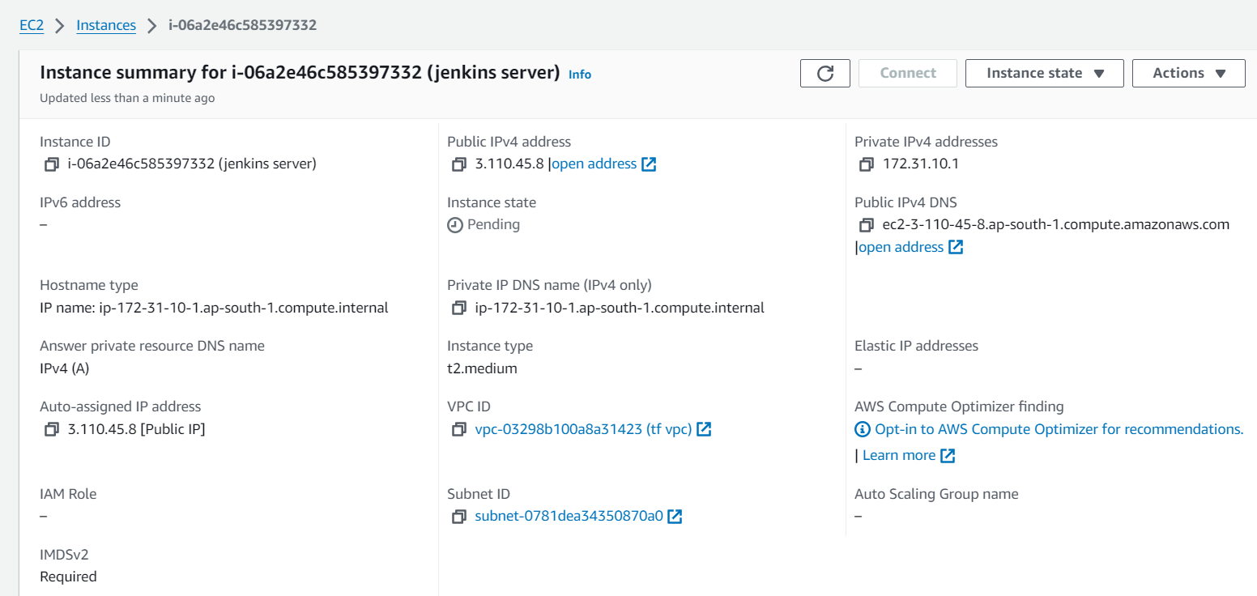

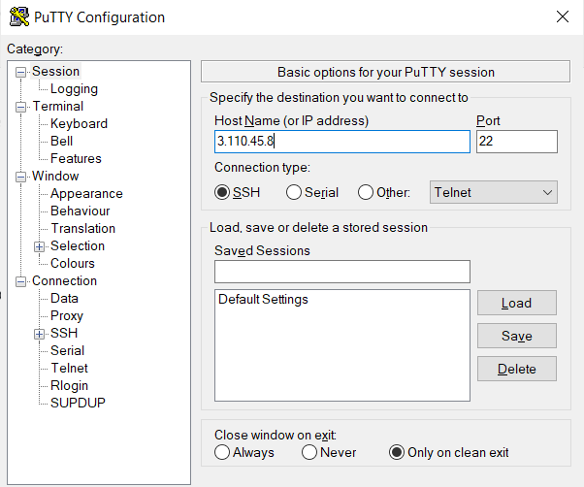

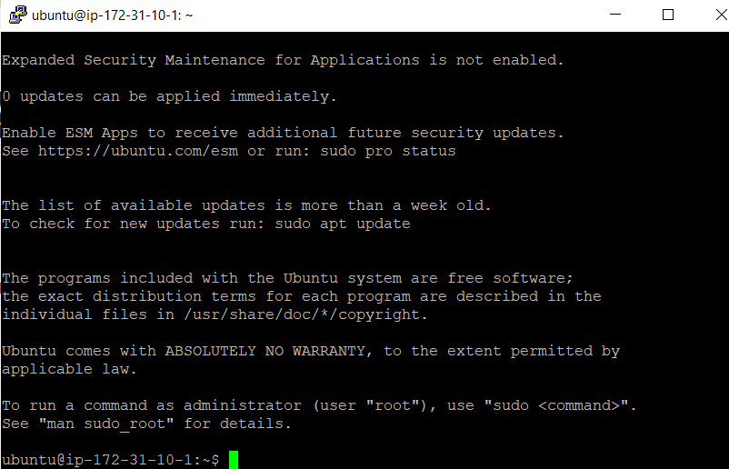

**First need to install Java on to the machine as Jenkins runs on java:**

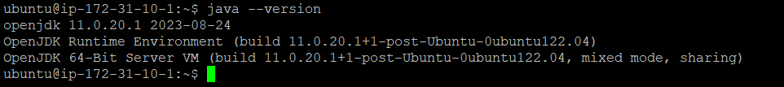

**Installed Jenkins on to the machine as below:**

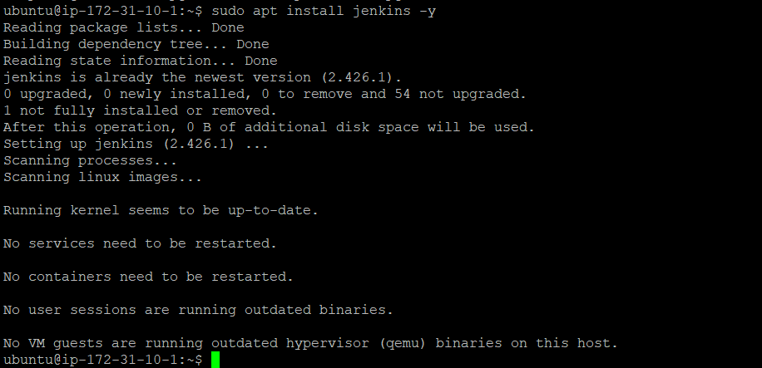

**Added port 8080 entry to the SG**

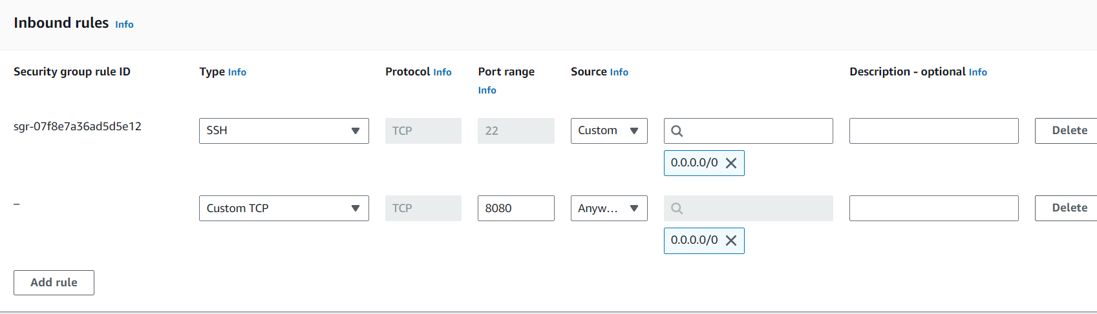

**After adding port entry hit ip-port on to the browser and unlock the Jenkins.**

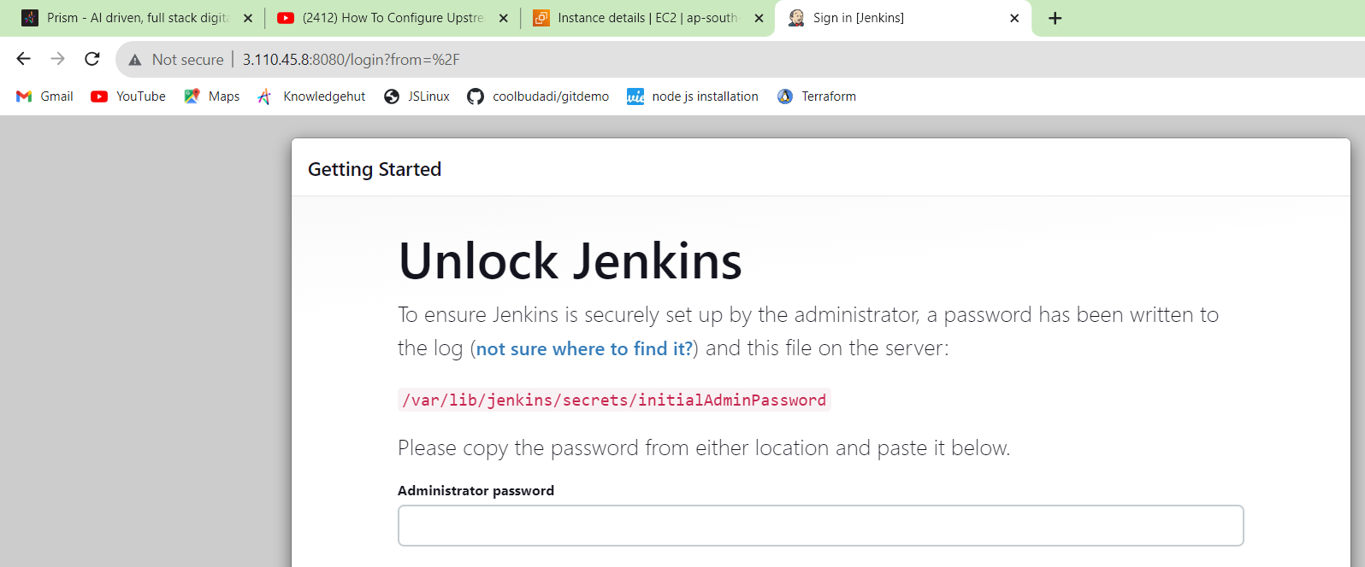

**For administrator password cat the above path and use the content as password as below:**



**Installing required plugins:**

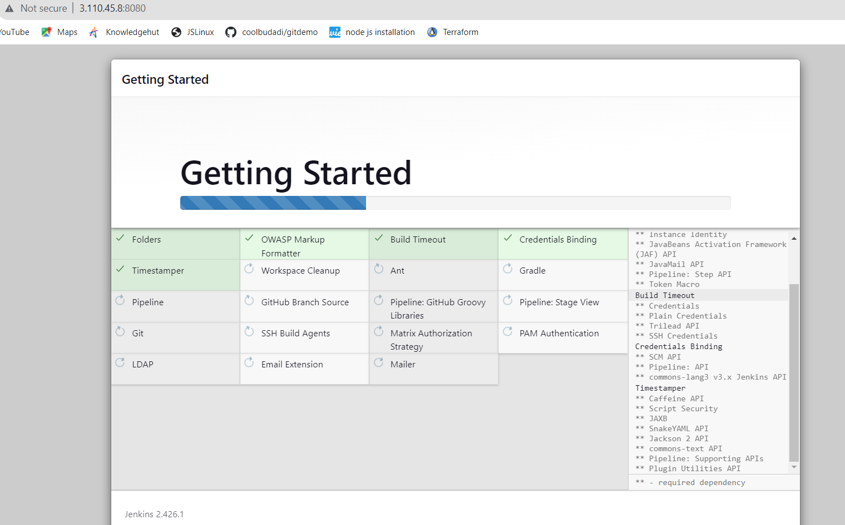

**Settings the username / Password as below :**

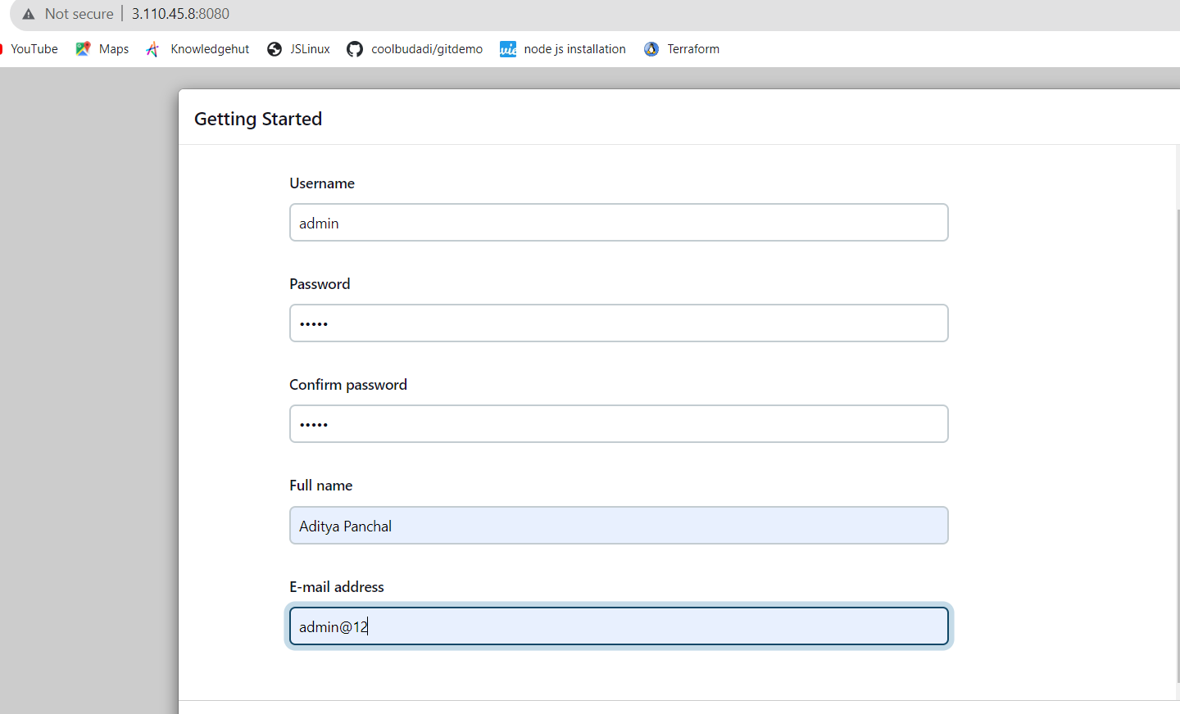

**Now Jenkins ready as below:**

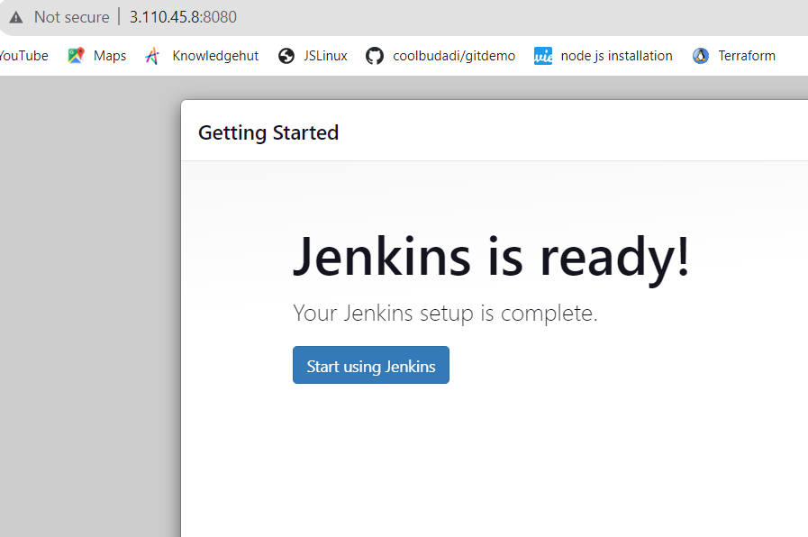

**And Below is Jenkins dashboard which is running on to the port 8080:**

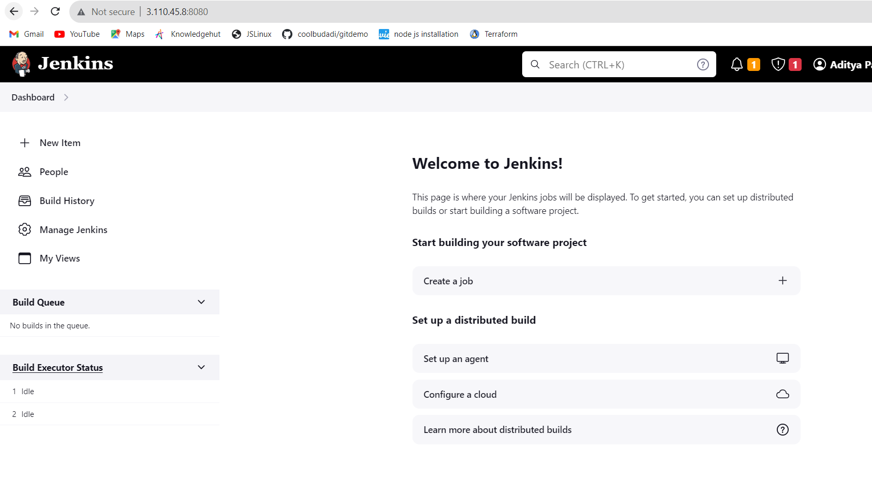

* **Login to Jenkins and create a new freestyle job “Continuous Integration”**

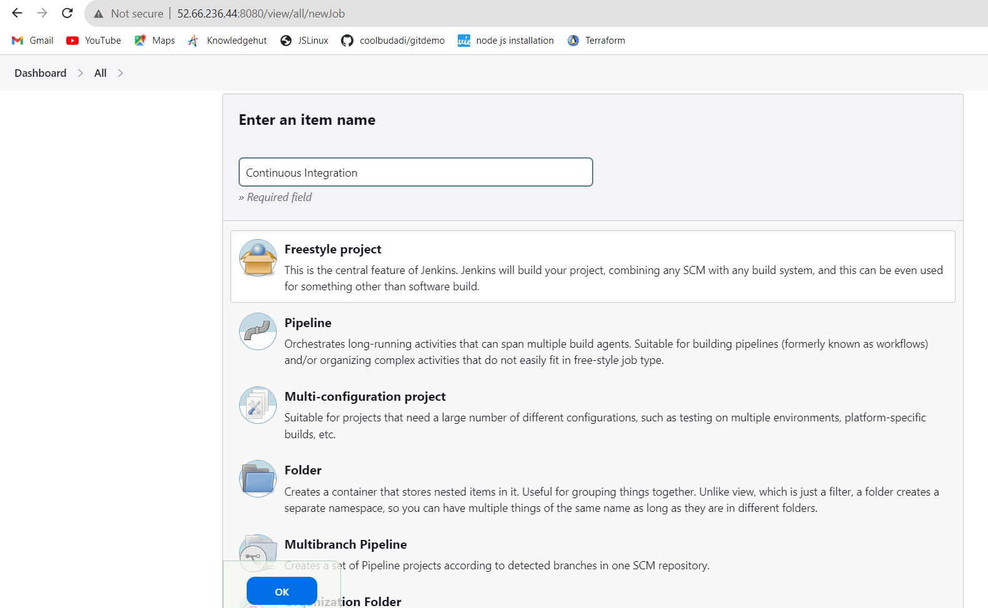

* Add execute shell build step which should navigate to jpetstore6 folder and build app using maven:  
   cd jpetstore6  
  ./mvnw clean package -Dlicense.skip=true

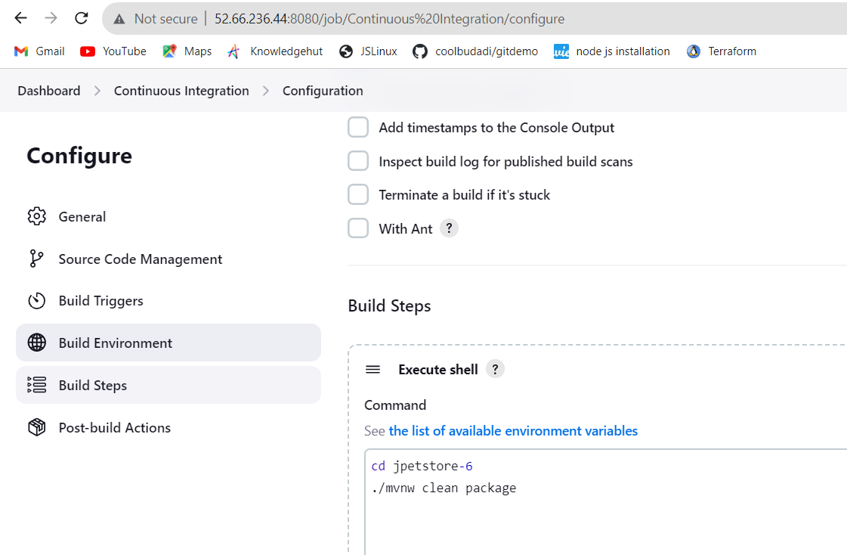

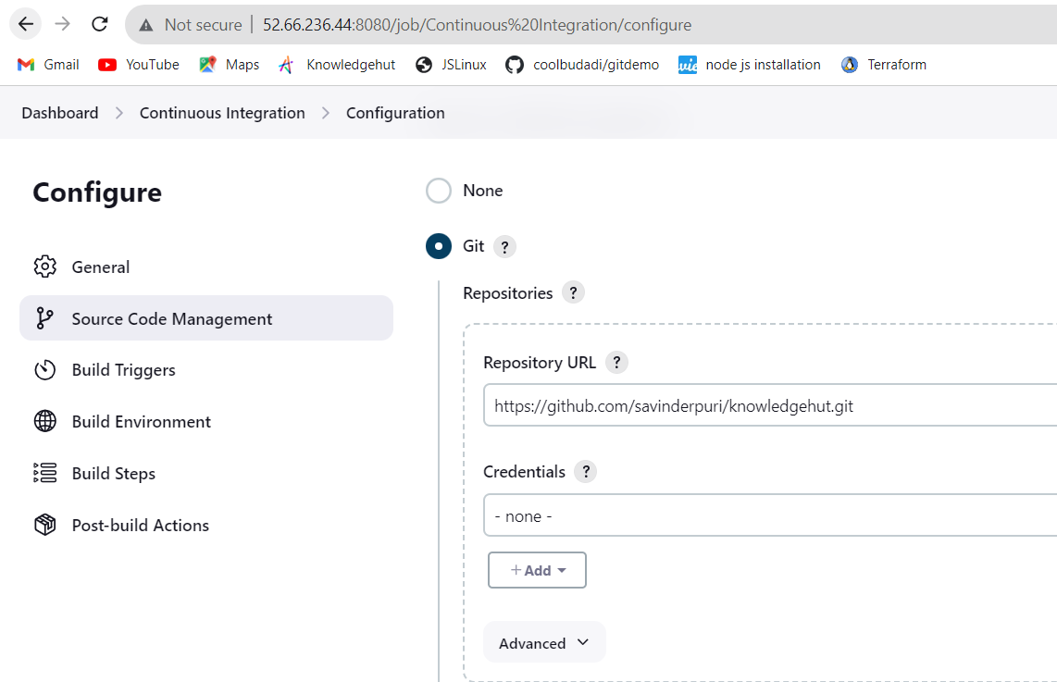

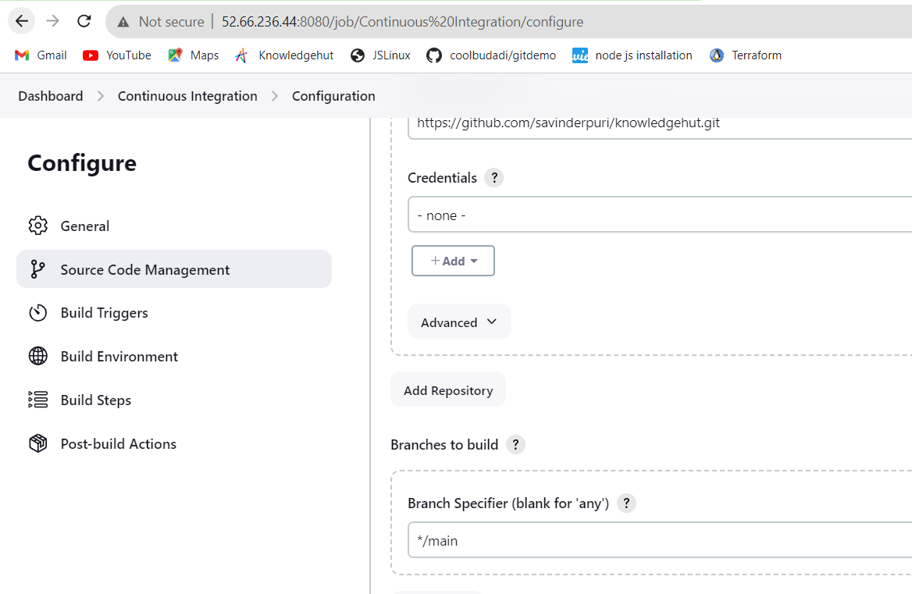

And got successful result as below:

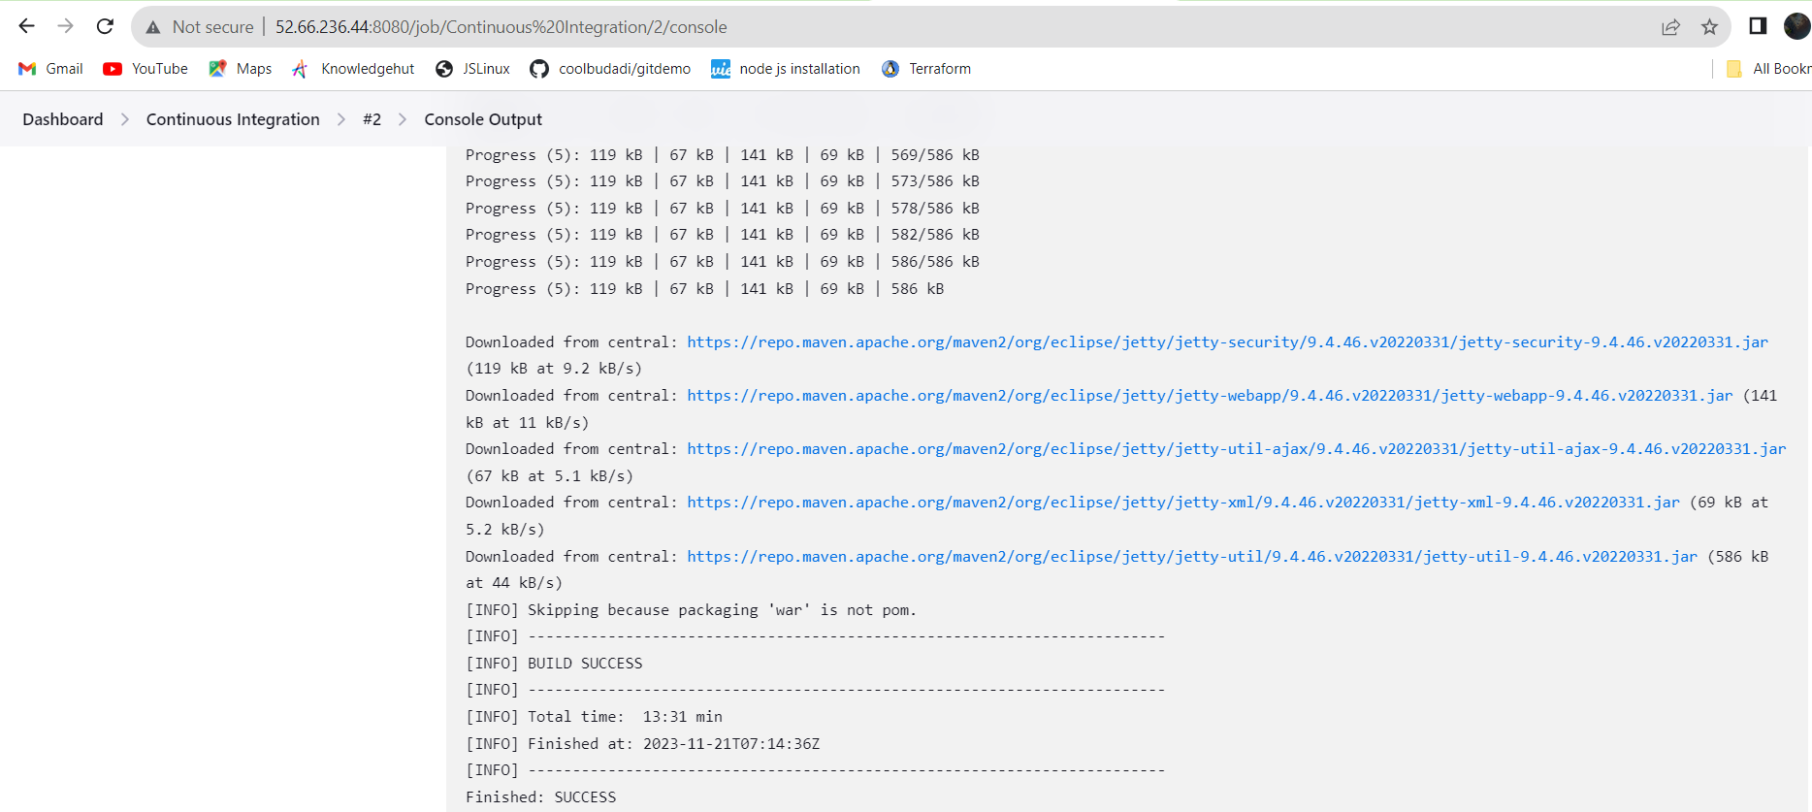

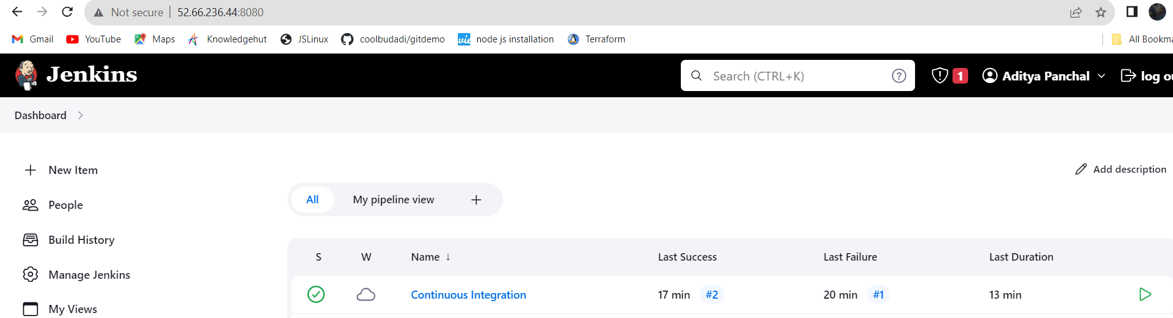

**Installed “Copy Artifact” plugin through Jenkins Plugin manager**

**(manage jenkins->manage plugins”**

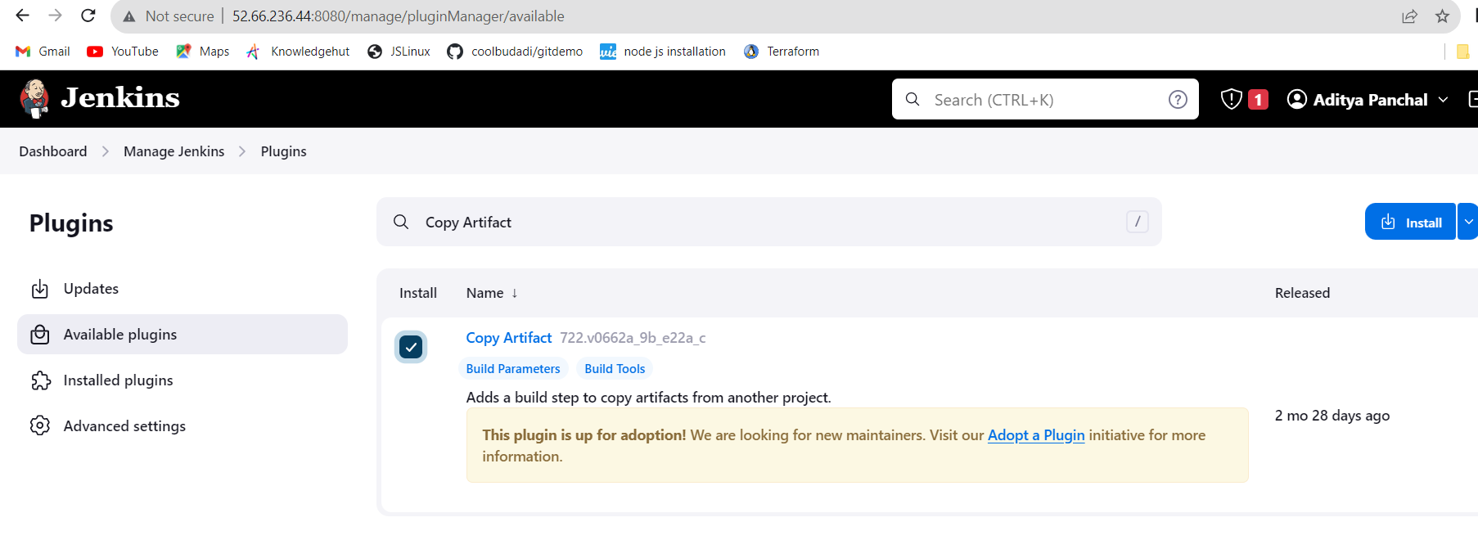

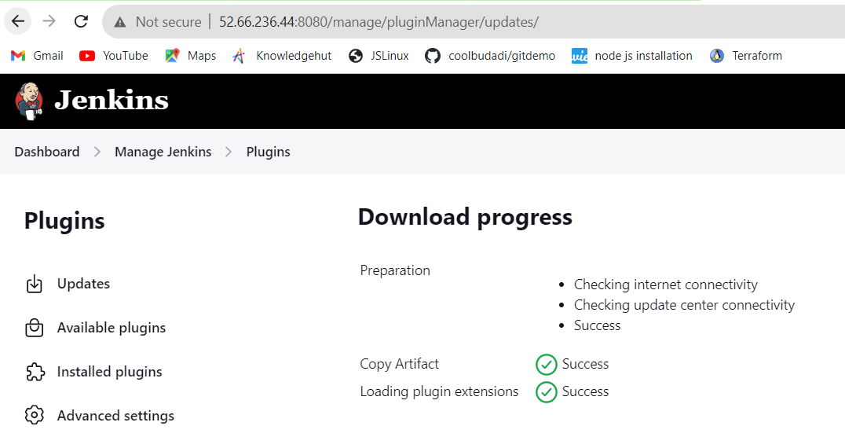

* Created a new freestyle job “Continuous Deployment” and a new freestyle job “Continuous Testing”

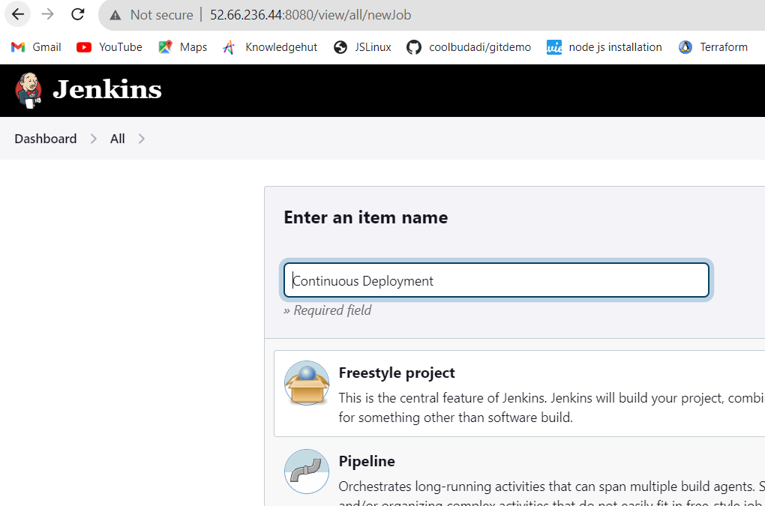

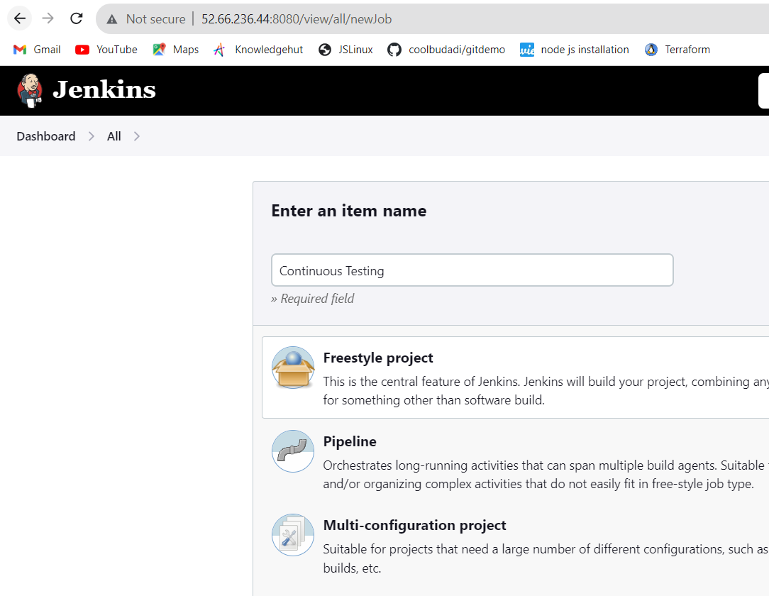

In the “Continuous Integration” job and select the “Permission to Copy Artifact” checkbox and specified “Continuous Testing” job. This will allow “Continuous Deployment” and “Continuous Testing” job to get artifacts produced by “Continuous Integration” job

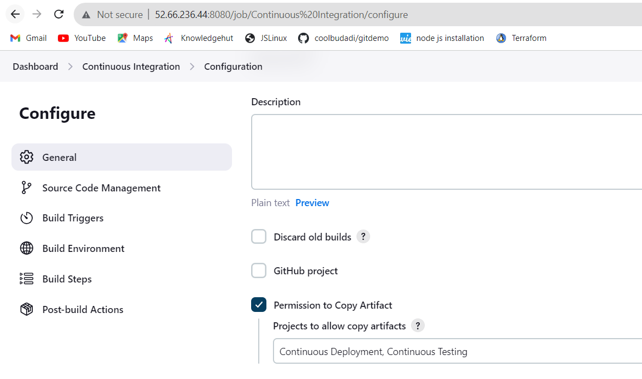

* Make sure you installed “JUnit Plugin” plugin through Jenkins Plugin manager (manage jenkins->manage plugins”

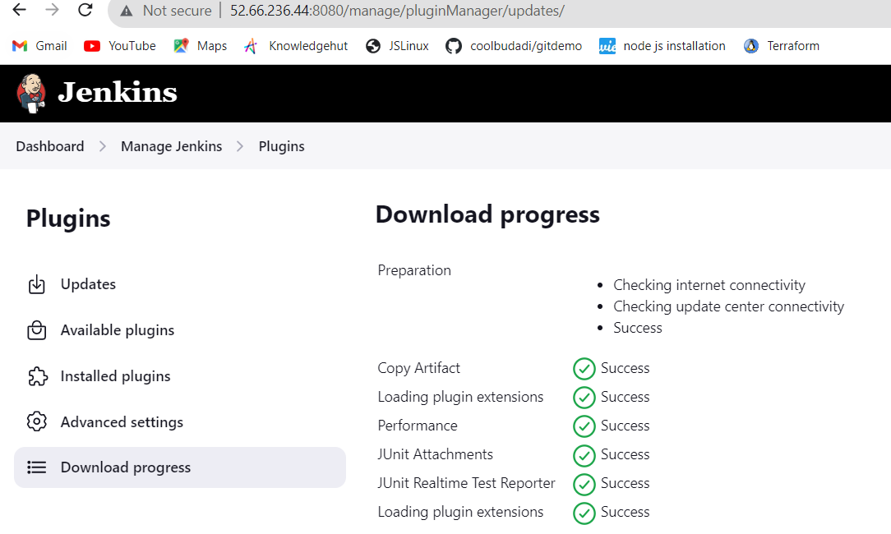

* In the “Continuous Testing” job, Scroll to the “Build Triggers” and select “Build after other projects are built”. In the “Projects to watch field” type in Continuous Integration.

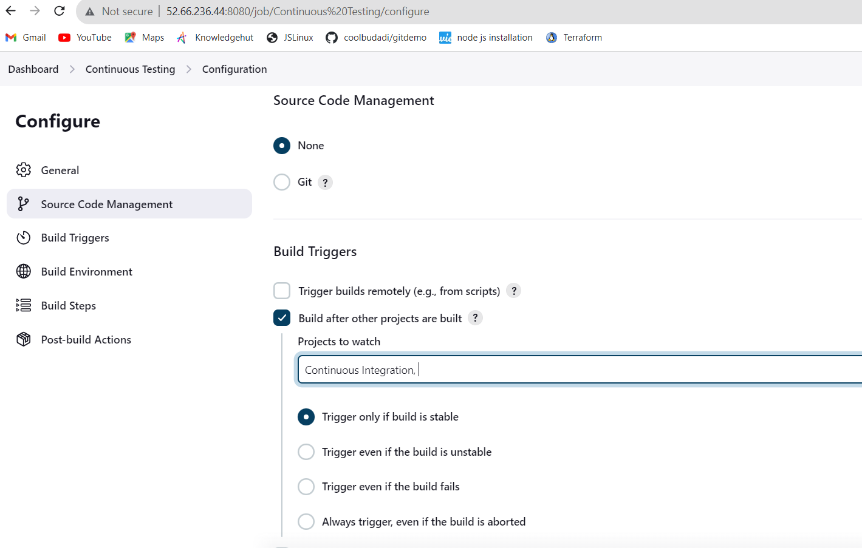

* In build steps select copy artifacts from another project and specify “Continuous Integration” job

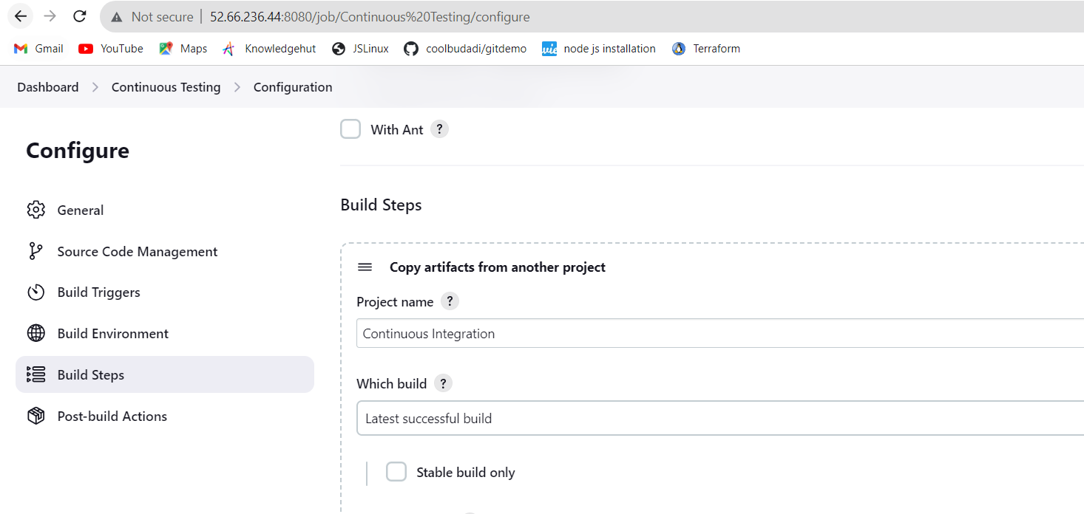

* build specified “Copy from WORKSPACE of latest completed build”

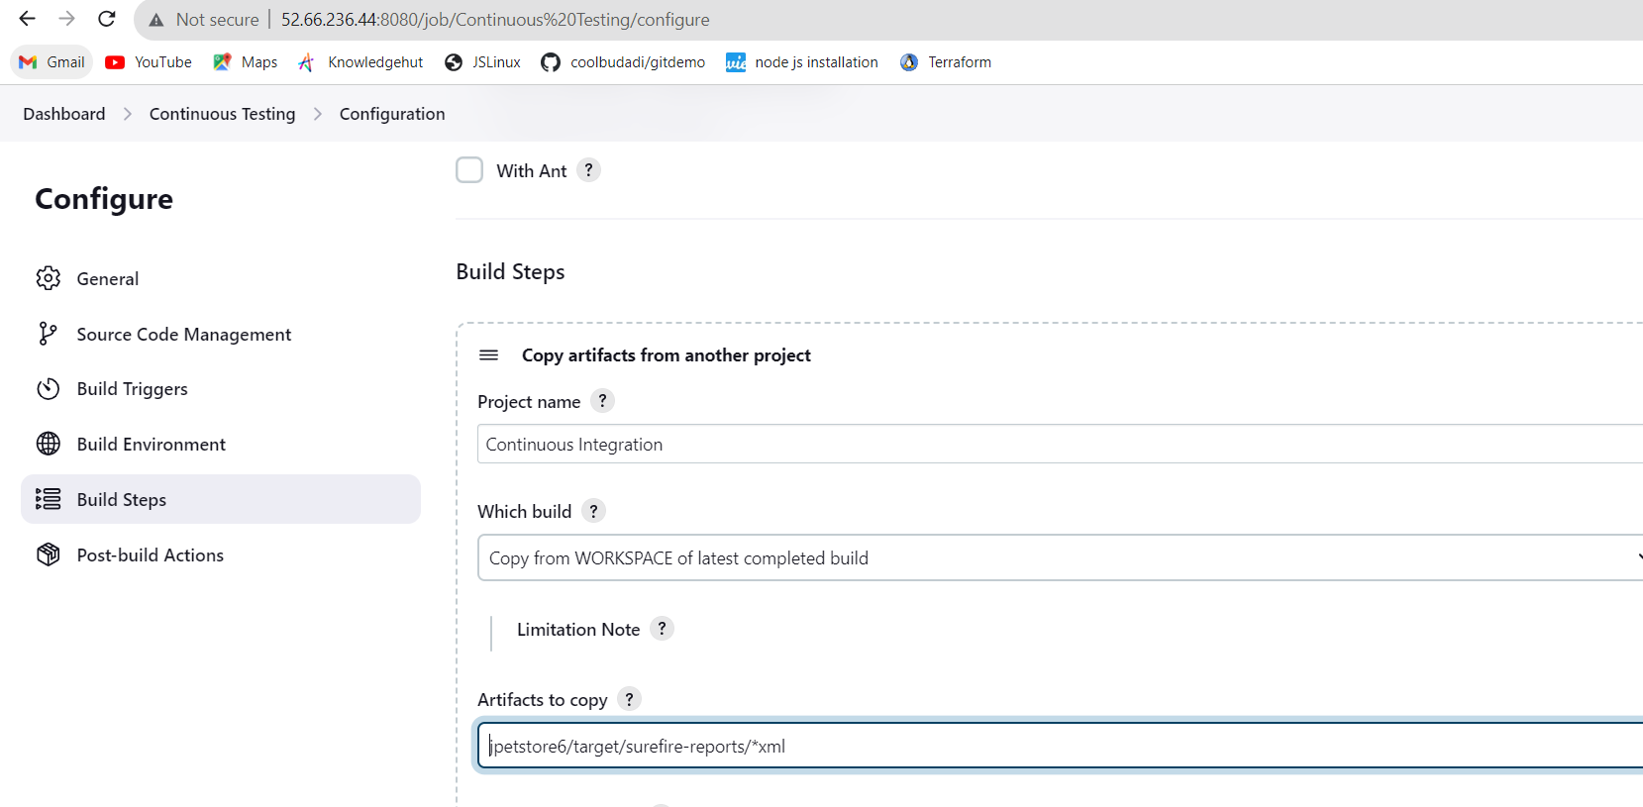

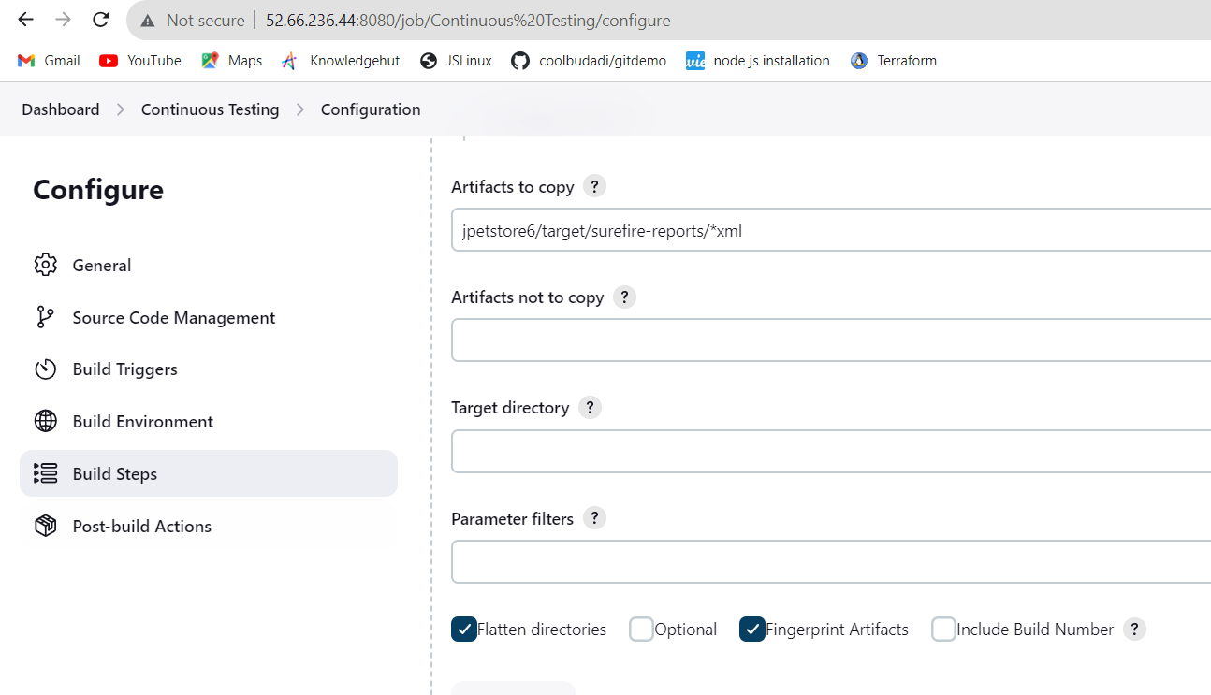

Added Post build actions and add “Publish JUnit test result report”

In the “Test report XMLs” field add *xml path and click “save”

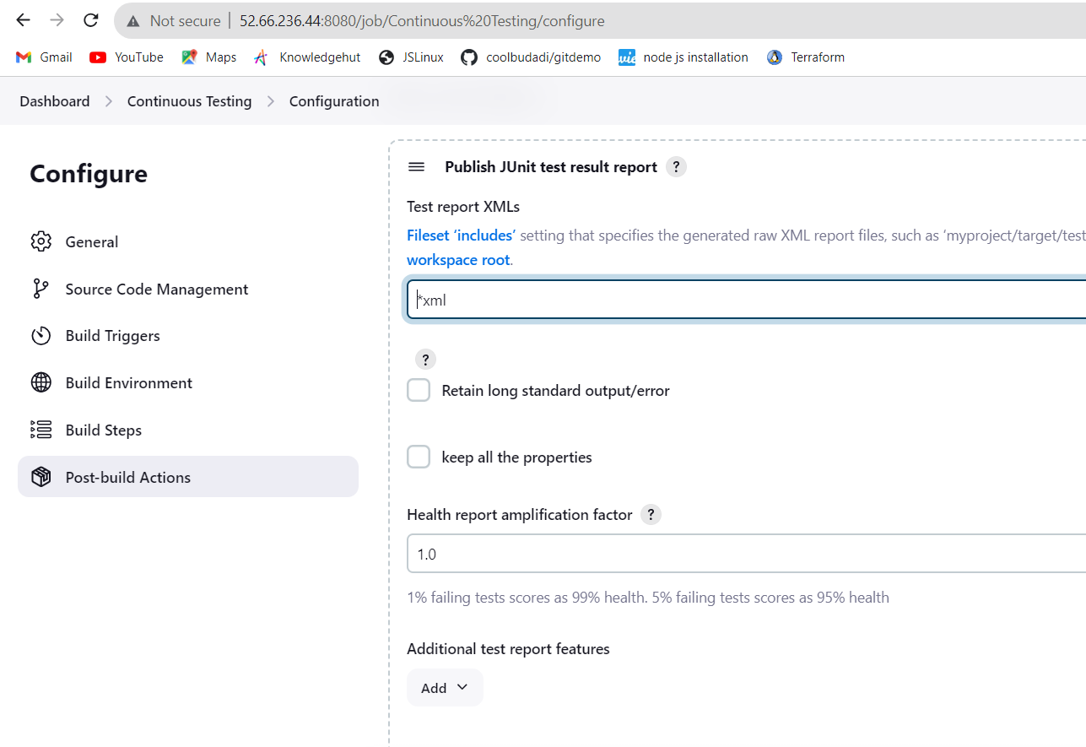

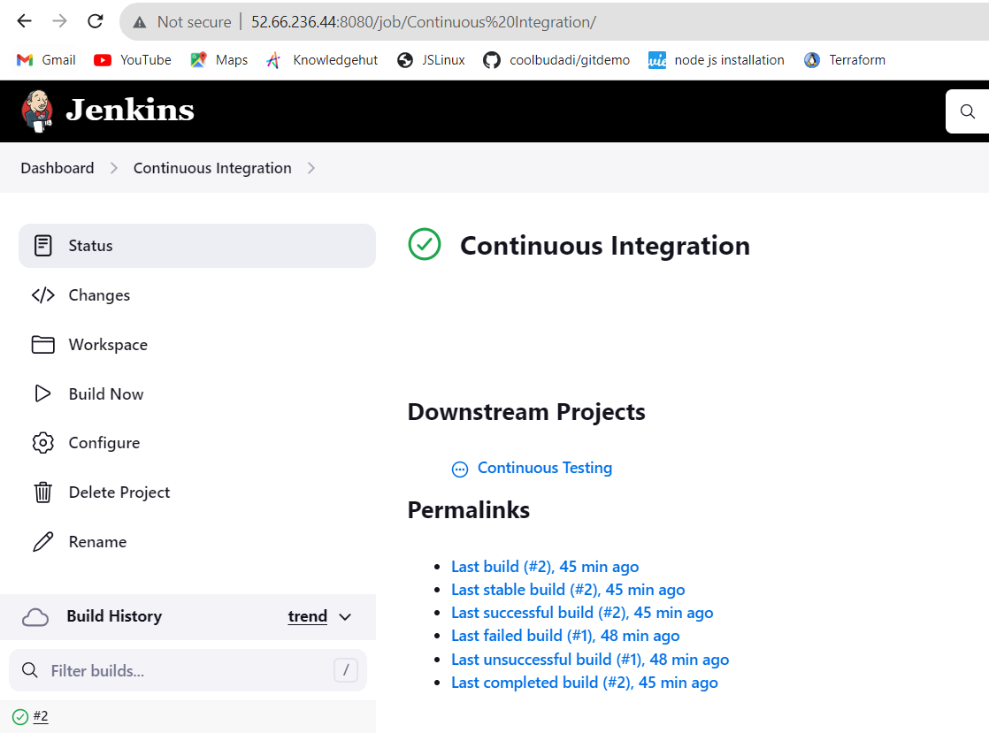

After built continuous Integration we got successful result as below:

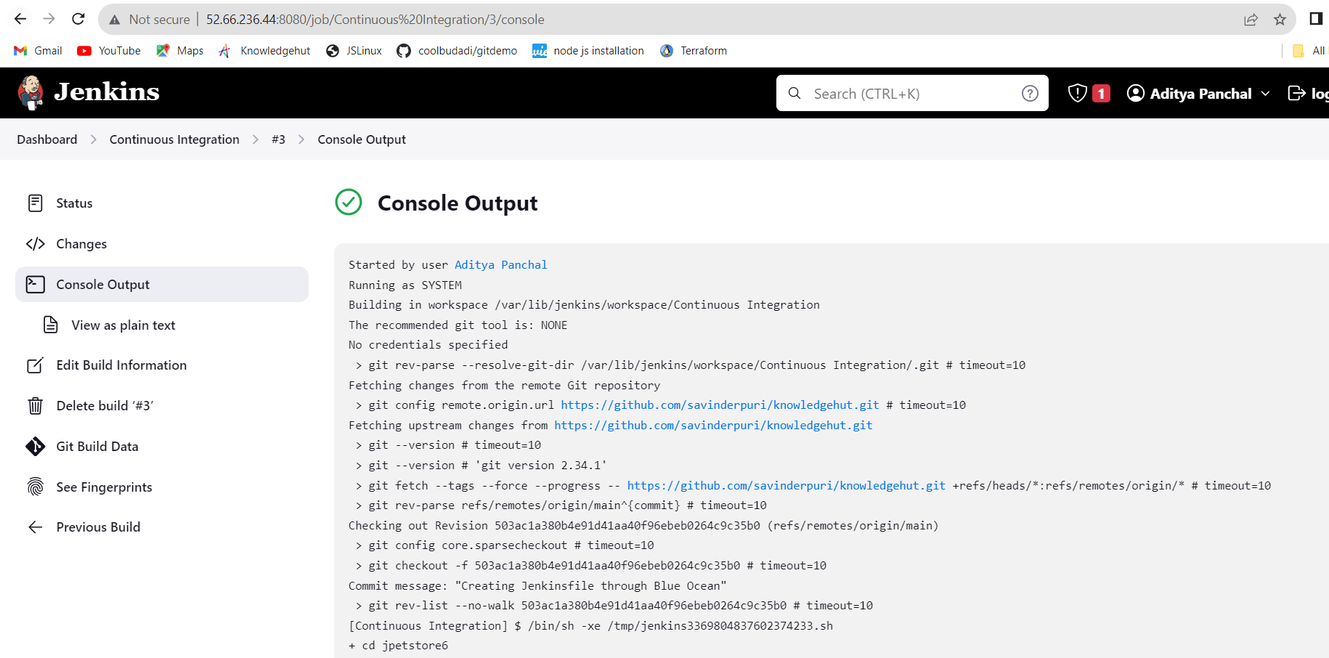

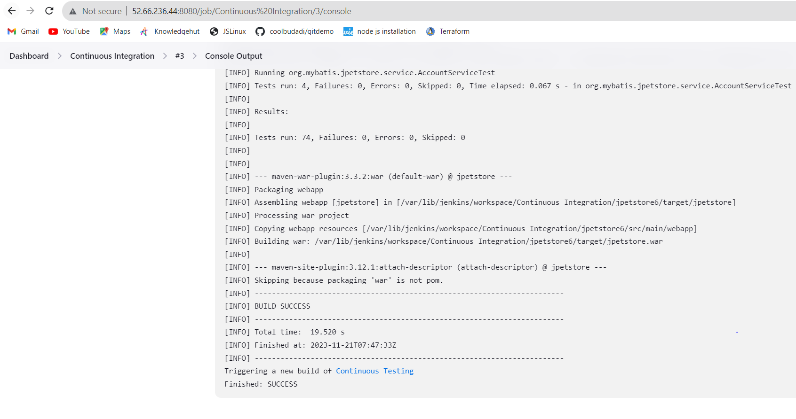

Now installed Tomcat on to machine as below:

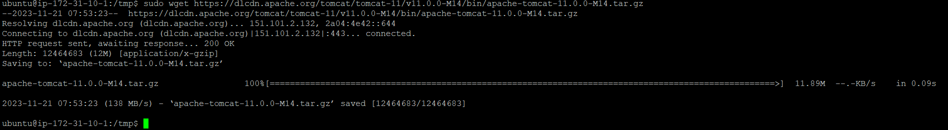

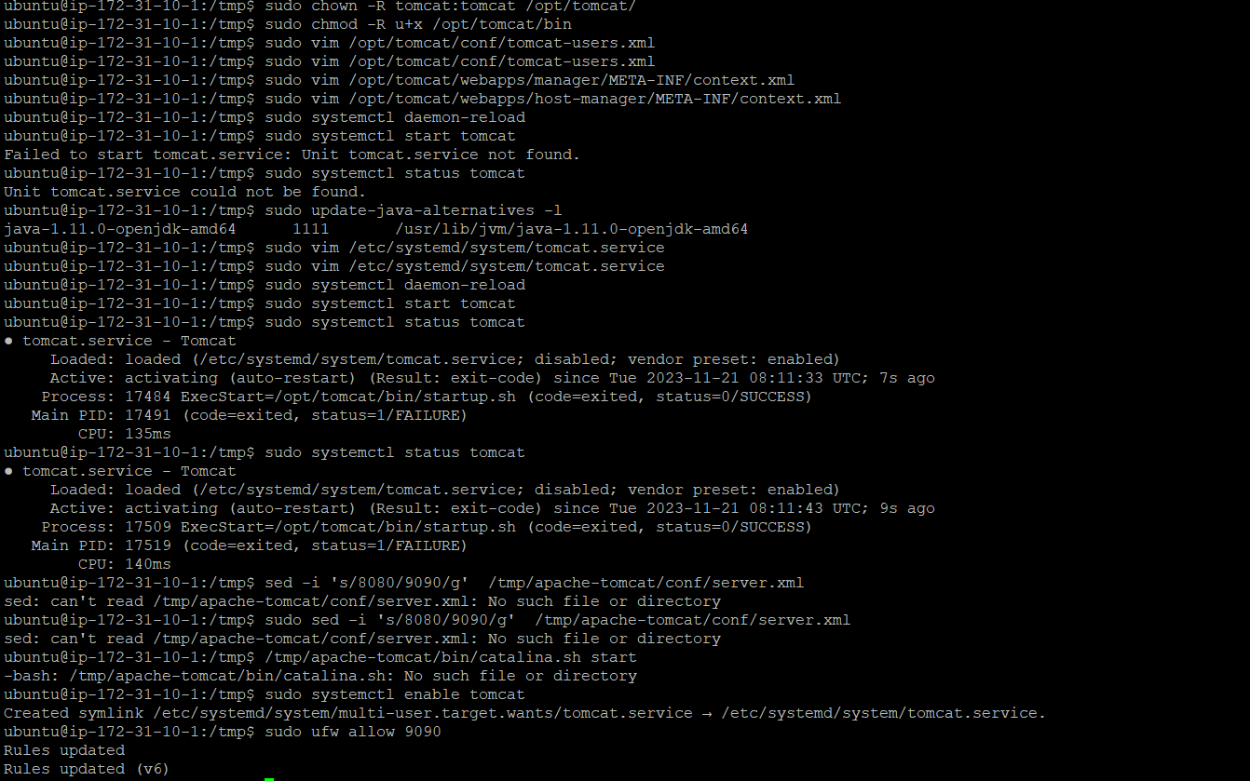

**Added port 9090 to SG in machine as below:**

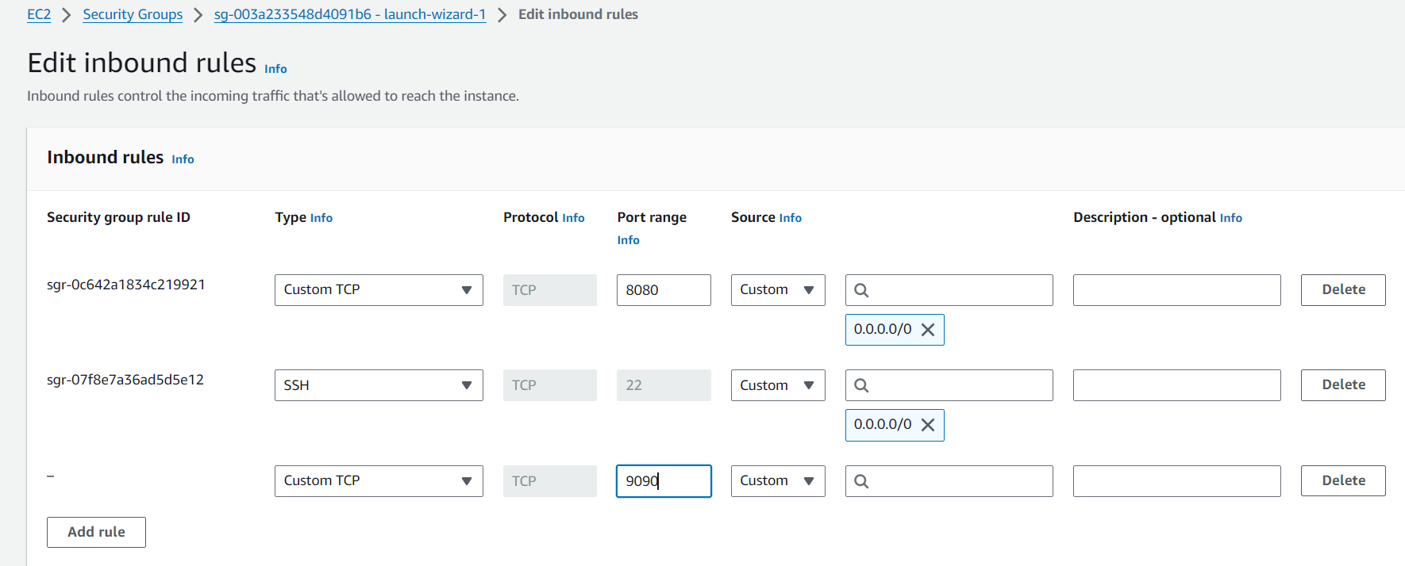

**CD:**

* In the “Continuous Deployment” job, Scroll to the “Build Triggers” and select “Build after other projects are built”. In the “Projects to watch field” type in Continuous Testing.

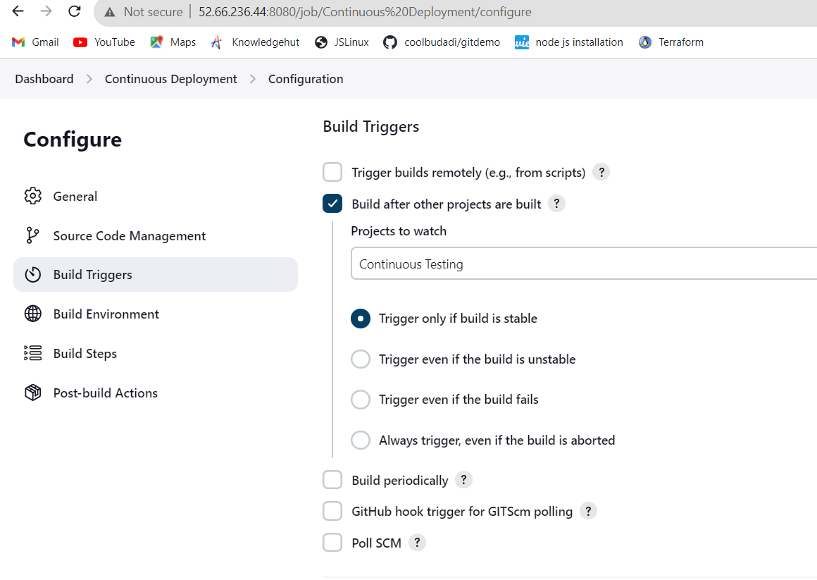

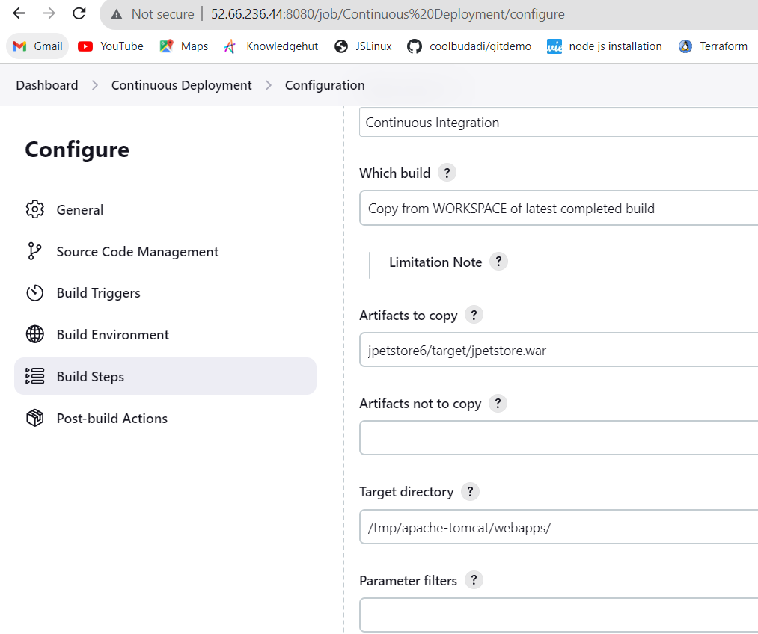

After configuring in CD we got successful result as below:

